| **Item** | **Details** |
| --- | --- |
| Information sheet | Allow as much time as required |
| Consent form | 1 copy for participant, 1 copy for research team |
| Participant ID | Only include participant ID on paperwork |
| Age |  |
| Sex (at birth) |  |
| Mass |  |
| Height |  |
| Dominant foot | Ask for dominant foot - which would they kick a ball with |
| Skin hardness | 12 locations |
| Monofilament test | 12 locations |
| Fit pressure insoles |  |
| Connect IMUs |  |
| Calibration trial |  |
| Standing balance | 60 seconds, point at eye-height on whiteboard |
| Standing on wobble board | 60 seconds, encourage looking at a specific point, allow to hold onto railing if needed |
| Walking - normal speed | Back & forth twice |
| Walking - fast | Back & forth twice |
| Walking - slow | Back & forth twice |
| Ramp walking | Up and down twice |
| Stairs | Up and down twice, no holding onto railing |
| Sit to stand | 90˚ angle at knee, hands on thighs |
| Sit to walk | 90˚ angle at knee, hands on thighs, walk for 5m |
| Drop jump | 2 footed landing |
| Jogging | Back and forth 3 times |
| Walking on gravel | Self-selected speed, back and forth twice |

Participant preparation - to be carried out at the table and plinth in the corner of the Motion Capture Lab

| **Item** | **Details** | **Notes** |
| --- | --- | --- |
| Information sheet | Allow for as much time as possible to read through, answer any questions |  |
| Consent form | Signatures on both copies. Enter details into spreadsheet |  |
| Participant ID | Record name and ID pair on the master spreadsheet only. Participant ID should be the only identifying factor on all data/documentation. | ID: |
| Participant Mass | Participant to stand on scales, take mass (kg) |  |
| Participant height | Participant to stand by measuring equipment, take height (cm) |  |
| Participant age | Record age (years) on spreadsheet |  |
| Participant sex | Record sex (at birth, M/F) on spreadsheet |  |
| Dominant foot | Ask participant which is their dominant foot (the one they would kick a ball with) |  |

Foot measurements - demonstrate on hands first so participant knows what the expect.

| **Item** | **Details** | **Notes** |
| --- | --- | --- |
| Foot hardness | Participant to lay on plinth, take shoes & socks off. Use durometer to take hardness at the centre of 8 regions of the foot. Enter details into spreadsheet. Instructions on final page. |  |
| Monofilament test | Use the Jamar monofilaments at the same 8 locations to detect sensory perceptual thresholds. Record results in grams on spreadsheet. Instructions on final page. |  |

|  | **Skin Hardness** | |  |  | **Monofilament test** | |
| --- | --- | --- | --- | --- | --- | --- |
| **Region** | **Left** | **Right** | **Region** | **Left** | **Right** |
| **T1** |  |  | **T1** |  |  |
| **T3** |  |  | **T3** |  |  |
| **MMe** |  |  | **MMe** |  |  |
| **MMi** |  |  | **MMi** |  |  |
| **MLa** |  |  | **MLa** |  |  |
| **AMe** |  |  | **AMe** |  |  |
| **ALa** |  |  | **ALa** |  |  |
| **Heel** |  |  | **Heel** |  |  |

Equipment preparation

| **Item** | **Details** | **Notes** |
| --- | --- | --- |
| Attach IMUs | Attach 3 IMUs, one to either shank, and the other on the lower back. Ensure these are synced |  |
| Fit insoles | Ensure participant is comfortable in the shoes. Run **step calibration** on TekScan research software. Allow participant to walk around to get used to the insoles and system. Note shoe size. |  |

| **Item** | **Details** | **Notes** |
| --- | --- | --- |
| Calibration trial 1  **trial00** | Ask participant to roll their foot, one at a time, over a tennis ball to actively apply pressure to every region of the foot. Begin standing still - stand on tiptoes for 10 seconds. Then stand on heels for 10 seconds. |  |
| Calibration trial 2  **trial01** | Both feet, left foot, right foot, both feet - 10 seconds each |  |
| Calibration trial 3  **trial02** | Both feet, flat, tip toes, flat, heel |  |
| Calibration trial 4  **trial03** | Both feet to left foot only |  |
| Calibration trial 5  **trial04** | Both feet to right foot only |  |

Basic balance and walking tasks - always starting with a stomp with the left foot, then standing still both feet on the ground before beginning movement. End with standing still on both feet for 3 seconds. Start IMU recording first, then participant to start trial when they are ready.

| **Item** | **Details** | **Notes** |
| --- | --- | --- |
| Standing balance  **trial05** | 60 seconds, arms by side, in silence, looking at a dot at eye-level. |  |
| Wobble board  **trial06** | Starting off of the wobble, then stepping on, balancing for 45 seconds, stepping off |  |
| Walking - self-selected speed  **trial07** | Back and forth twice |  |
| Walking - fast speed  **trial08** | “Like you are trying to catch a bus that is about to leave.” Back & forth twice “without running” |  |
| Walking - slow  **trial09** | “Like you’re walking with grandparents”. Back & forth twice |  |
| Sit to stand  **trial10** | Seat height so that knee is at 90˚. Hands on thighs. |  |
| Sit to walk  **trial11** | Seat height knee is at 90˚. Hands on thighs. 5 meter walk |  |

Standing movements - always starting with a stomp with the left foot, then standing still both feet on the ground before beginning movement. End with standing still on both feet for 3 seconds. Start IMU recording first, then participant to start trial when they are ready.

| Item | Details | Notes |
| --- | --- | --- |
| Twisting  **trial12** | Hands crossed on chest. Twist to the right, back to centre, twist to the left. |  |

**Mandatory 10 minute break**

More challenging tasks - always starting with a stomp with the left foot, then standing still both feet on the ground before beginning movement. End with standing still on both feet for 3 seconds. Start IMU recording first, then participant to start trial when they are ready.

| **Item** | **Details** | **Notes** |
| --- | --- | --- |
| Ramp walking  **trial13** | Using ramp in front of Hadfield main entrance - outside. Participant to walk up and down the ramp twice. |  |
| Stairs  **trial14** | Head to the stairs outside of the MoCapLab. Participant to start with left foot on the bottom step and climb. Turn and stop at the top. Start with right foot on the top step and come down. Repeat twice. |  |

Extremes of pressure - - always starting with a stomp with the left foot, then standing still both feet on the ground before beginning movement. End with standing still on both feet for 3 seconds. Start IMU recording first, then participant to start trial when they are ready.

| Item | Details | Notes |
| --- | --- | --- |
| Jogging  **trial15** | Back into MoCapLab. Jog back and forth 2 times. |  |
| Drop jump - both feet  **trial16** | Stand on the single step with railings. Jump down, landing on both feet. |  |
| Drop jump - left foot  **trial17** | Stand on the single step with railings. Jump down, landing on left foot. |  |
| Drop jump - right foot  **trial18** | Stand on the single step with railings. Jump down, landing on right foot. |  |
| Walking on gravel  **trial19** | Set tarpaulin down. Spread gravel across. Participant to walk back and forth twice at a speed they feel safe in doing so. |  |
| Calibration trial 3  **trial20** | Both feet, left foot, right foot, both feet - 10 seconds each |  |

| Item | Details | Notes |
| --- | --- | --- |
| Finish up | Thank participant. Clear tarpaulin and gravel. Turn off equipment. |  |
| Record length of experiment and any urgent notes | Including any participant issues (incomplete trials - record reason e.g. participant had to attend commitments), number and length of extra breaks |  |

Researcher name (BLOCK CAPITALS): ………………………………………………………………...

Date: ………………………………………………………………...

Researcher signature: ………………………………………………………………...

Lead researcher signature: ………………………………………………………………...

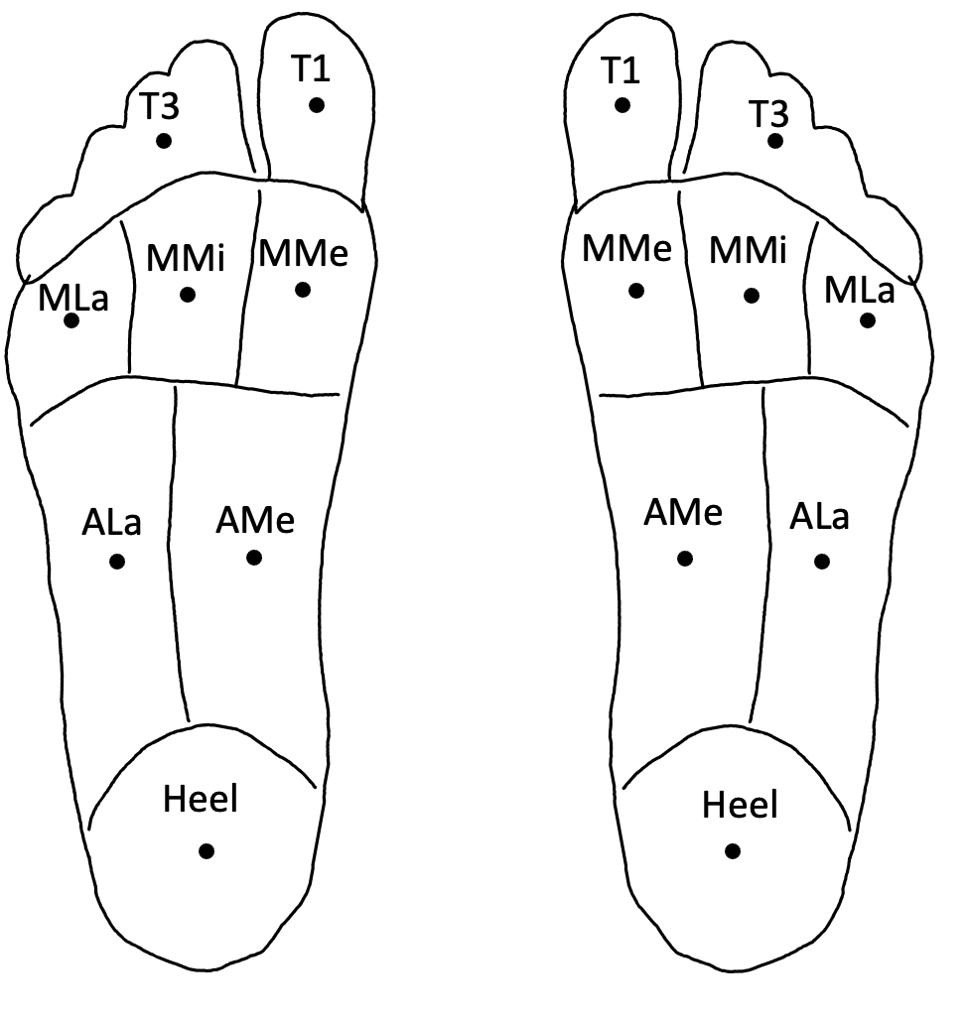

Skin hardness measuring instructions:

* Show the participant the durometer and demonstrate how it works by testing on their index finger
* Participant to lie down with shoes and socks off
* Starting at the great toe, hold the durometer perpendicular to the foot surface and press gently until the tip has receded into the durometer
* Note down result on spreadsheet

*This does not have to be randomised as it is an empirical measurement*

Monofilament test instructions:

* Show the participant the monofilaments and instruct them that they will be presented to the foot at multiple regions and is designed to find perceptual thresholds. Provide an example on the index finger
* Participant to lay down with shoes and socks off so they cannot see their feet
* Keep noise to a minimum
* Participant instructed to say “touch” when they feel that they have been touched.
  + Participant must include location that they feel the touch - can point on a picture of a foot
  + Test this with the thickest monofilament (T, Red, 447.0g)
* Present monofilament B (2.44, Green) first
  + Hold monofilament perpendicular to the foot surface
  + Push until the monofilaments does not bend any further
  + Hold for approximately 2 seconds
  + Release
* Randomly choose the next test location

*Avoid testing on scars. Ensure that the test locations are as close to the hardness locations as possible. Repeat twice per foot to ensure reliability*

